Documentation PG framework

Introduction
Everything that belongs to the fysio game is in the FysioGame folder (red outer rectangle). All assets that belong to the PG generation library are in the PGFramework folder (green inner rectangle). In theory you should only have to change the PGFysioTester script.

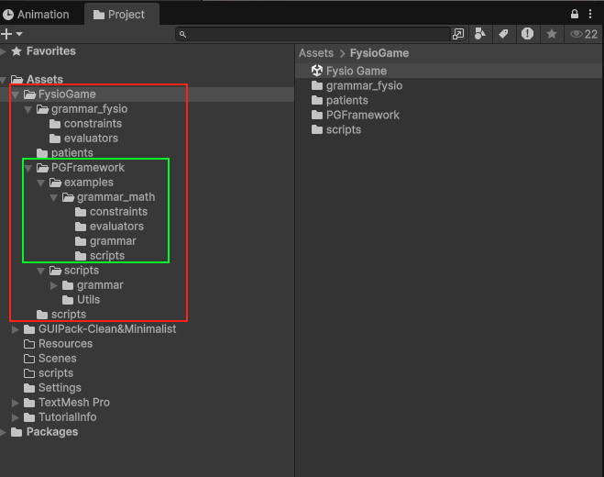
Run the project and see the output of the generation in the console, for example:
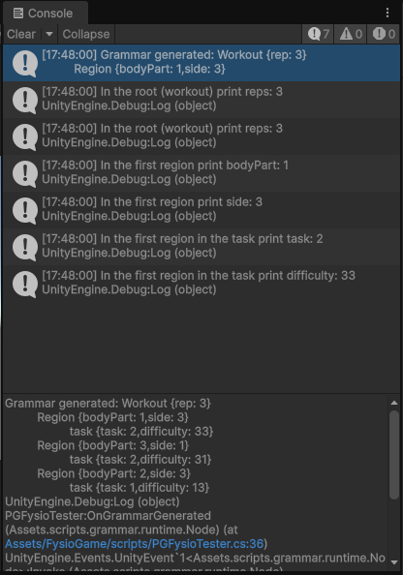
The output is a workout with 3 repetitions (rep). The first rep focusses on bodyPart 1, on side 3, and the player should do a task of type 2 with a difficulty of 33. See chapter 3.Generated output for an explanation of these numbers.
The printlines below this, show how you access these elements from code (double click them in the console), or open the PGFysioTester.cs script and see the method:
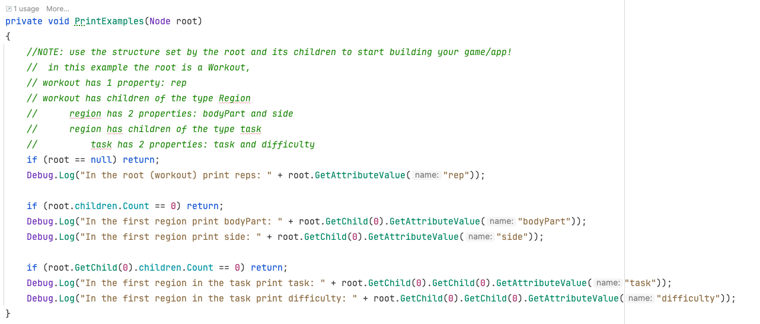

What scripts should you know about?
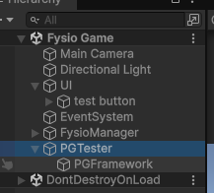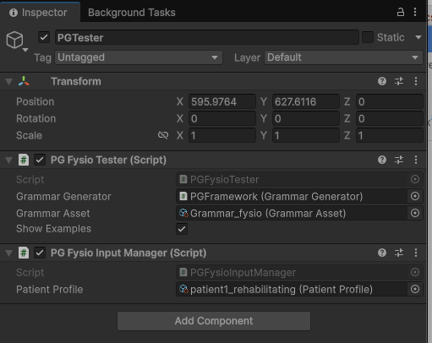

PGFysioTester: Entry point for your game generation
In the Fysio Game scene see the gameObject: PGTester -> PGFysioTester. This script will call the ‘StartNewGeneration()’ function on the attached GrammarGenerator. Once the generation is done the OnGrammarGenerated(Node root) method in the PGFysioTester is called. This is your entry point to start building your specific game! You could for example call a method on one of your scripts, or use events. (It also calls the PrintExamples(Node root) method, this is to show examples and can be safely removed)

PGFysioInputManager: Configure the input values for the generator
The PGFysioInputManager loads a PatientProfile. This is a scriptable object in which you set the parameters for the next generation. Some patientProfiles are already made and ready to be used. You can drag one of these in the PGFysioInputManager -> Patient Profile property.
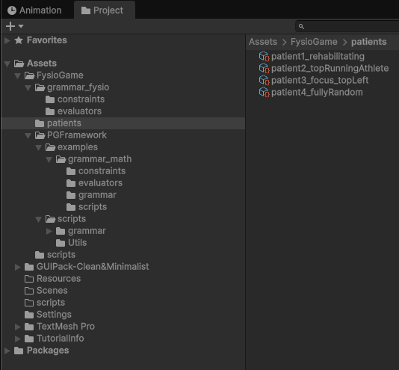
You can also modify these profiles, or create your own. See the chapter Extra -> Creating your own Patient Profiles for more info about how to create your own patient profiles.

It is recommend only changing the settings shown above, because time is limited. But if it interests you, you are ofc always free to tinker with any script or alter the Grammar that is used!

Generated output
When the generator is finished the OnGrammarGenerated(Node root) in PGFysioTester is called. It receives a single parameter: root (of type: Node). But this root has child nodes again, and these have children again, etc! This creates a tree of data. Although each node is of the type Node, it represents a specific element from the fysio domain.
The tree should look something like this (depending on your input properties it could contain more/less nodes):
Workout (0.*) Region (0.*) Task

These elements have the following properties, these all are represented as an integer(int):
Workout:
- rep: The number of repetitions (basically how many regions it will contain)
Region
This object represents a single repetition in the workout, the region contains data about what region in the body should be targeted.
- bodyPart: What body part should be targeted (0=arms, 1=legs, 2=chest)
- side: What side of the body should be targeted (0=left, 1=right, 2=center)
Task
Each Region has a single Task object. This object contains data about the type of task that should be performed for this single repetition.
- task: The type of task the patient should do for this repetition (0=follow, 1=hit, 2=dodge)
- difficulty: a number between 0-N (set in the patientProfile). Use this value to let your game set the difficulty for this specific repetition.

Tips to get started:
After generating the children, loop over the output. See the example methods TraverseTree(..) and OnNodeVisited(..) in the PGFysioTester class (also see the screenshot below).
When a node is visited you should do something that is specific to your game. For example, if a Region node with bodyPart:1, side:0, task: (task: 1, difficulty: 51) is visited. It could (plan to) spawn a monster (at some point) that you need to destroy with bodyPart 1 (legs) and is spawn on your left side (side 0 = left). You need to use your hammer to smack it (task 1= hit). Because the difficulty is set to 51 the monster moves rather quickly!
This ofc is just an example! Maybe in your abstract game no monsters are spawn, but the player needs to hit specific colors to mix them to something new? Use your own creativity to translate these values to a unique game experience! But make sure it still aligns with the goals for the physiotherapists (use a certain body part and side, etc).
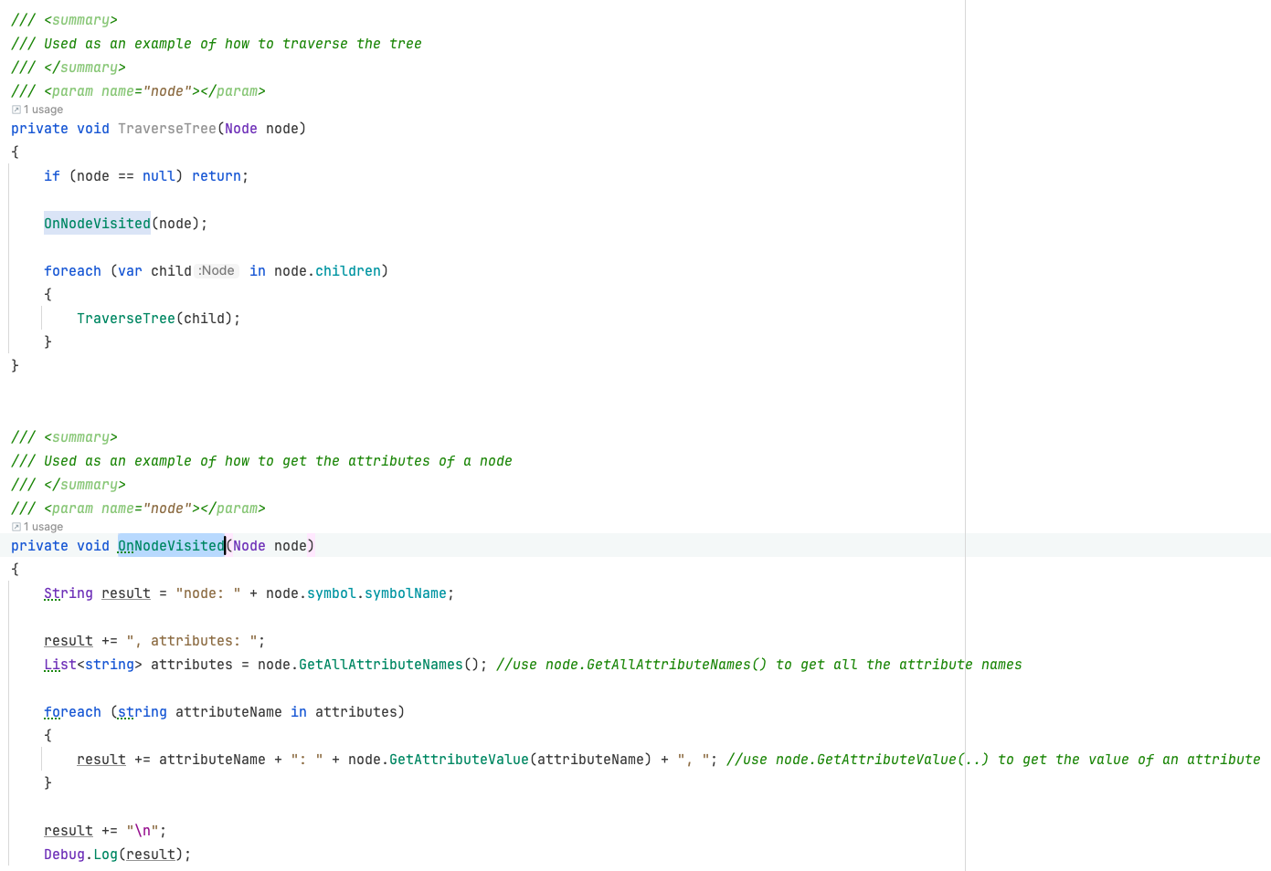

Extra
This chapter contains optional info. It should be needed to get started

Creating your own Patient Profiles
You create a new one by right mouse clicking in a folder and ‘create -> Fysio -> Patient Profile’. See below:
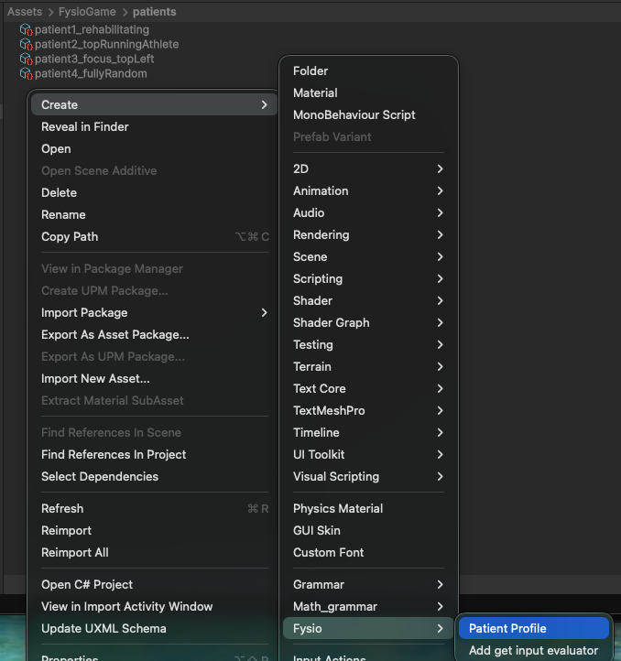

You can also setup your own patient profiles. You need to setup what the relative frequency is of each specific option for each property. For example, in the screenshot below: the side property has a chance to be set to 0 (weight 6), to 1 (weight 1) or to 2 (weight 3). (see chapter Generated output to see what these values mean in relation to Side).
Relative to each other this determine the chance. In this case the total weight is 10 (6+1+3). Because of that it has 60% (6/10) to become 0, 10% to become 1 (1/10) and 30% to become a 2 (3/10).
This means if all options in a property are equal it is fully random, if an option is set to 0 it is excluded.
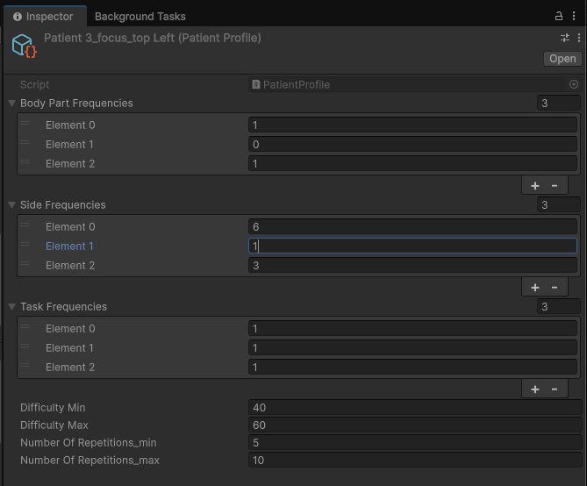

Node structure
The output is tree of objects from the Node class, connected to each other. A parent node can have child Nodes. If so, the child notes have a parent property linking back to the parent. A node can have properties, for example the ‘difficulty’ value. (also see the PrintExamples(Node root) method in the PGFysioTester class, on how to access these properties (or see the screenshot above).
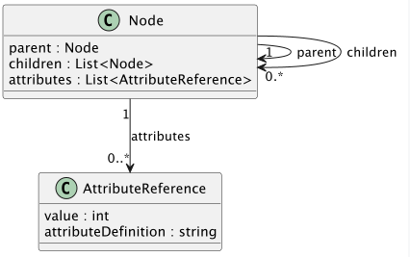
Also see the debugger below:
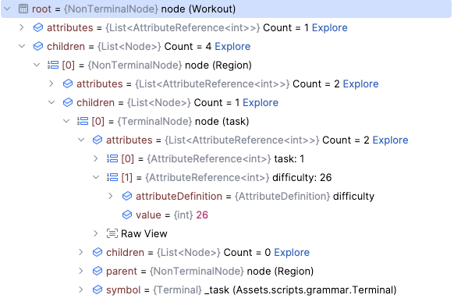

Math Example (extra)
To see the math example, open the ‘PG Math Sample Scene’.
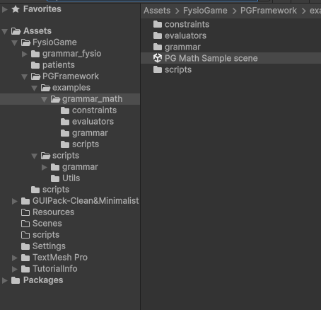
Run the game and open the console log
